VERIFY-X WORKING SNAPSHOTS
HOME PAGE –
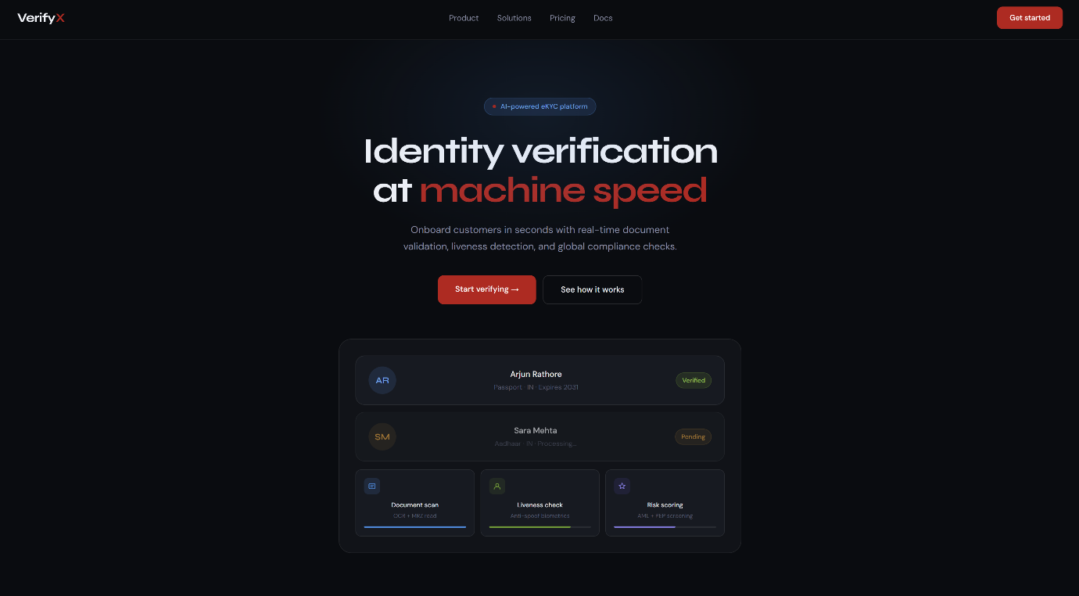
KYC METHOD SELECTION PAGE –
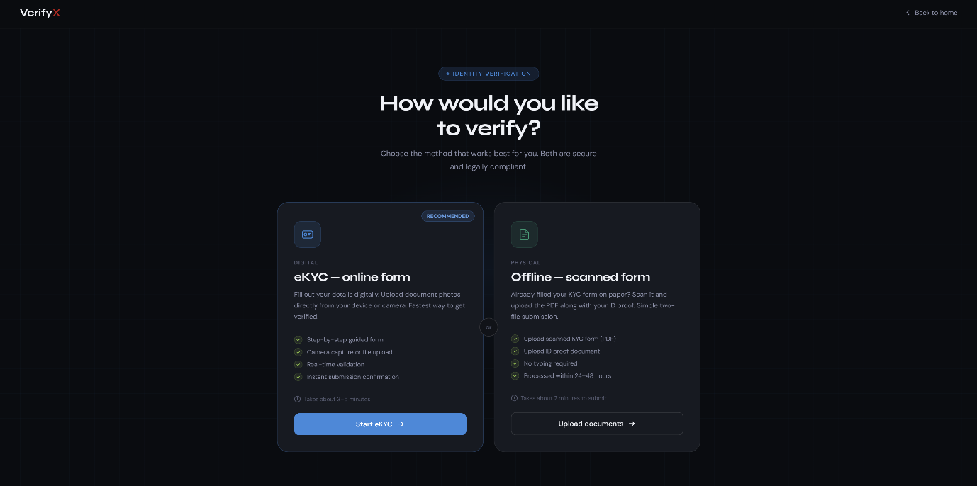

OFFLINE KYC FORM –
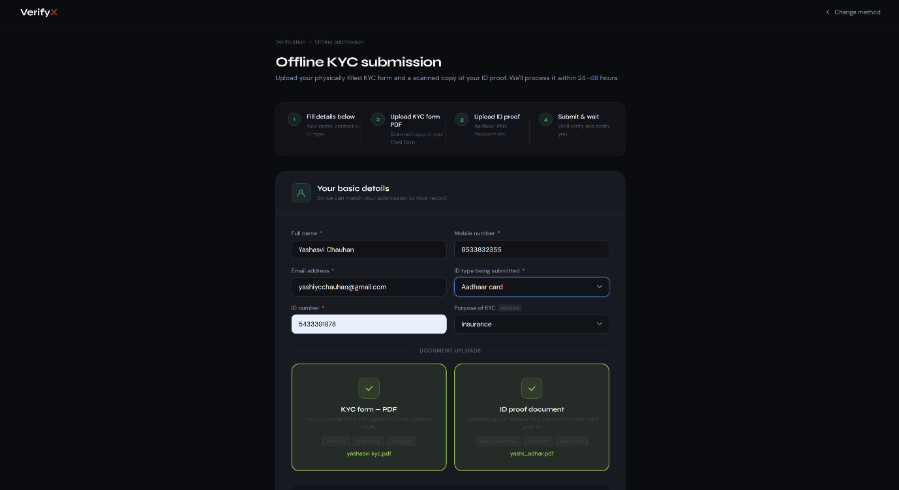
eKYC FORM –
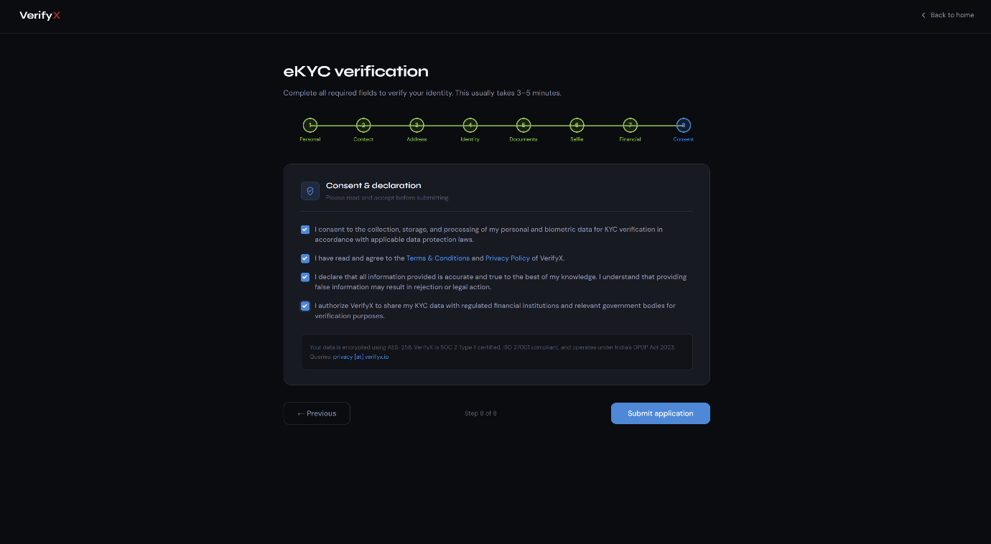

RESULTS PAGE (REJECTED) –
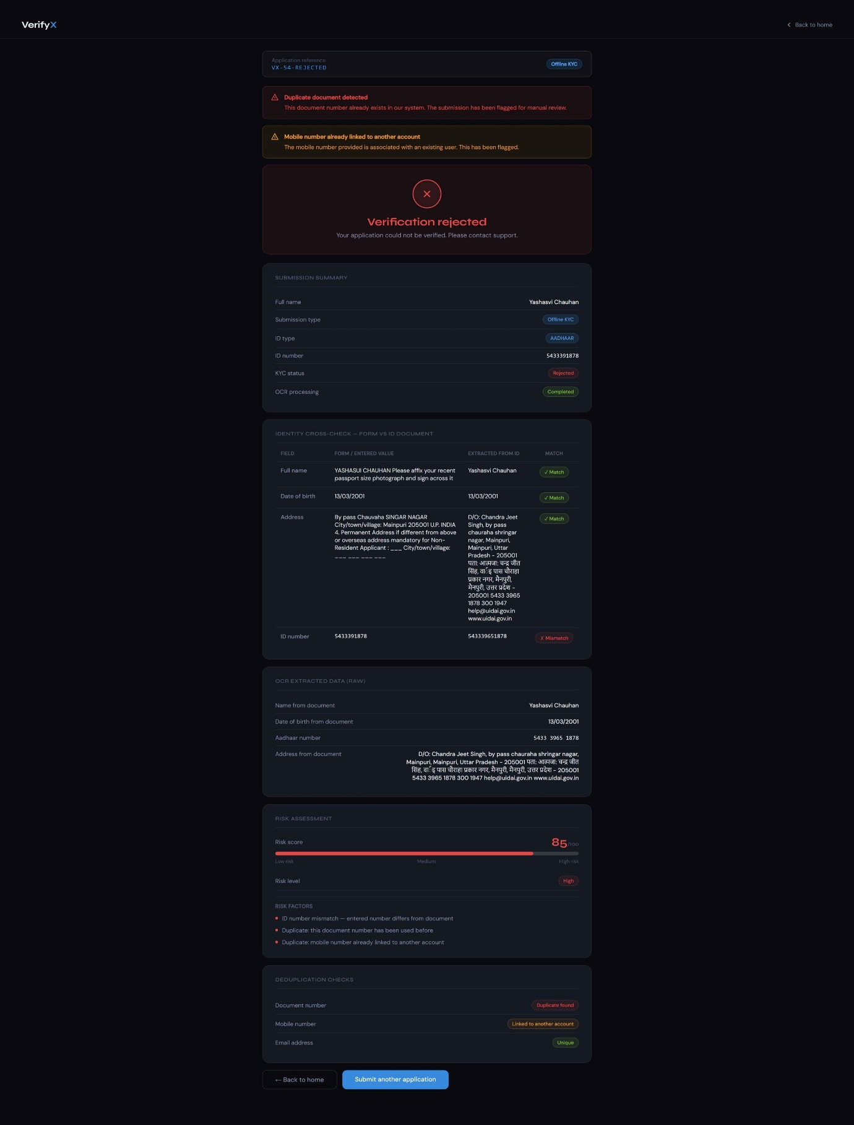

RESULT PAGE (UNDER REVIEW) –
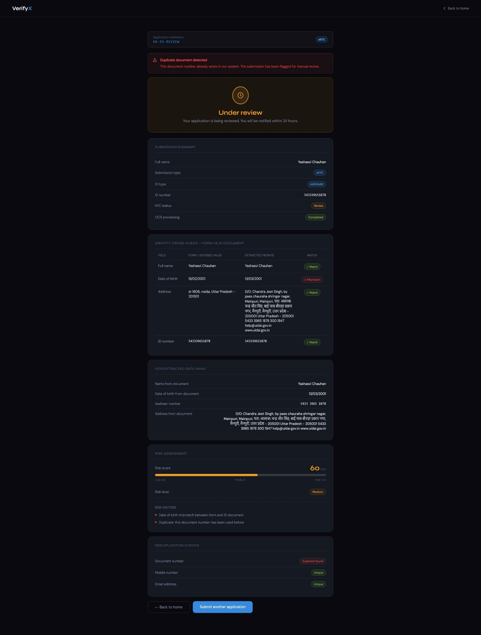

RESULT PAGE ( APPROVED) –
